Cornerstone of Academy WI

Web:

[www.csawis.com](http://www.csawis.com)

Email:

[new@csawis.com](mailto:new@csawis.com)

Call for assistance after 4pm: 262-592-4679



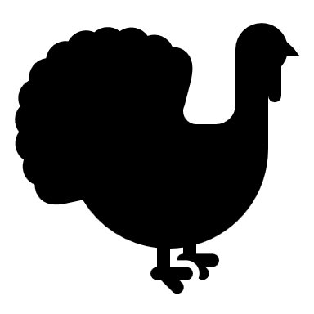

**Holiday Schedules-** if your child’s schedule is going to change during the holiday season please let Ashley or Madison know so your billing can be adjusted accordingly. If you would like to use **Vacation Days,** please let us know so those credits can be applied to your account. We will credit for the days we are closed (Thanksgiving, day after Thanksgiving, etc).

**Important Upcoming Dates:**

**November 1rd**- Daylight Savings Time make sure to change your clocks and replace batteries in smoke detectors

**November 5th-** EBT payment Due

**November 10th-** Picture day at CSA

**November 11th**- Veteran’s Day

**November 11th**- Conferences 6:15-8:15pm, there are signup sheets posted outside your child’s classroom.

**November 24th**- Thanksgiving Feast, no lunch needed

**November 26th and 27th**- **CORNERSTONE CLOSED**-HAPPY THANKSGIVING!

**December 24th -December25th**- **CORNERSTONE CLOSED**-MERRY CHRISTMAS!

**December 31st-January 1st**- **CORNERSTONE CLOSED**- HAPPY NEW YEARS

**Conferences-** Our annual fall conferences will be held Wednesday November 11th from 6:15pm until 8:15pm. There are signup sheets outside your child’s classroom, each conference is about 15 minutes long and is a great way to chat with your child’s teacher(s) about your child’s progress at Cornerstone. Please note we use the CORE Assessments to help us; but the assessment is strictly based on what teachers observe here.

**Friendly Reminders**

* If your school ager is transported to BOSE or Harvey in the morning, please make sure your child arrives no later than **7:00am**
* When dropping off your child please make sure to acknowledge the teacher that is in the classroom or outside on the playground
* Parents with the EBT card please make sure you pay your **FULL** amount by the 5th of each month

**Sick Policy**- Friendly reminder to all parents; with cold and flu season upon us please keep your little ones home if they show ANY symptoms of an illness until the symptoms diminish. Your child will be sent home if he/she shows any of the following symptoms:

* A temperature of 100 degrees F or higher
* Vomiting or diarrhea more than twice while present at the center
* A contagious disease such as chicken pox, strep throat, or pink eye
* An unidentified rash
* Has a constant, thick colored nasal discharge

**School Age Parents-** If your child will be attending winter break please let Madison or Ashley know so your billing can be adjusted as well as for staffing purposes. Also, parents with the EBT card please make sure your request additional hours from your worker to avoid those charges being billed to your personal side. Please see Ashley or Madison if you have any questions.